# Year 8 Revision Homework

1. 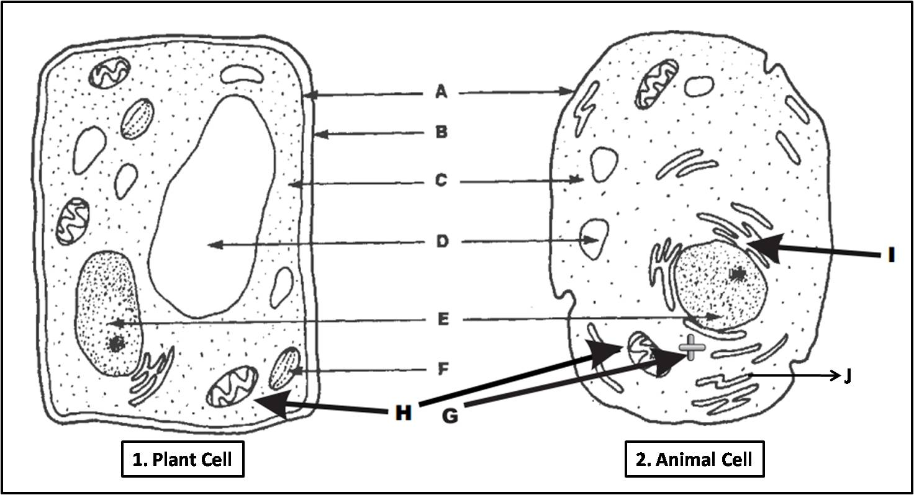Label the following cells;

2. Describe what each of these organelles do?

Chloroplast

Golgi apparatus

Mitochondria

Nucleus

3. Name the organelles that only belong to a plant cell

4. Name the process by which plants make their food

5. What is the difference between multicellular and unicellular organisms?

6. What are the two types of cellular division and what is the end products of each?

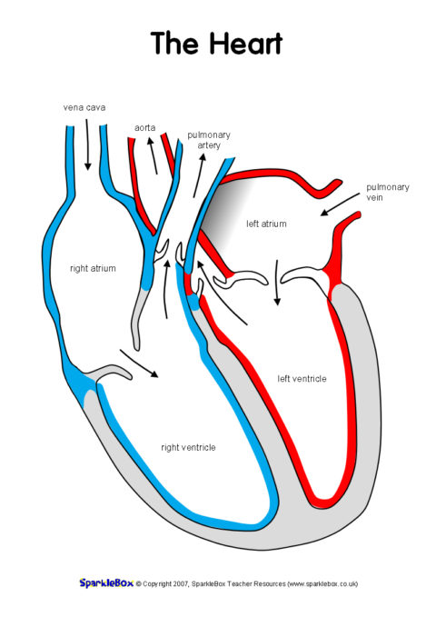

7. Describe veins and arteries and what they carry, the colour and whether they flow towards or away from the heart

8. Write in order the flow through the digestive system

9. What are the main components of the excretory system and what waste is associated with each?

10. Can you write the requirement of life for each initial of MRS C GREN?

M

R

S

C

G

R

E

N

11. Name an example of a prokaryote and a eukaryote

12. What is one specialized cell in the body and what is its function (hint. Think about reproduction)

13. Describe the reproductive cycle and process of fertilization

14. What is the levels of organization in the body in order?

15. What are the main components of blood and what component is involved with fighting infection?

16. What is the function of the alveoli and what two products are exchanged?

17. What is the difference between asexual and sexual reproduction?

18. Name the phases of mitosis

19. Draw a flow chart of how oxygen is carried into and throughout the body, and how CO2 is excreted.

20. Explain the difference in function between the small intestine and the large intestine in the digestion of food

21. Label the parts of female and male reproductive systems

